Task On ASG
1. Create one VPC in N. Virginia region.
Objective:
To create a Virtual Private Cloud (VPC) in the N. Virginia (us-east-1) region using the AWS Management Console.

Prerequisites:
- AWS account
- Access to the AWS Management Console
- Permission to create VPC resources
- Internet connection

AWS Services Used
- Amazon Web Services
- Amazon VPC

Step 1: Login to AWS Console, Select N. Virginia Region & Create VPC.
- At the top-right corner, click the Region dropdown.
- Select: US East (N. Virginia)
- Open VPC Dashboard
- Search for VPC in the AWS Console search bar.
- Open VPC.
- From the left-side navigation menu, select Your VPCs.
- Click Create VPC with CIDR range 10.0.0.0/16
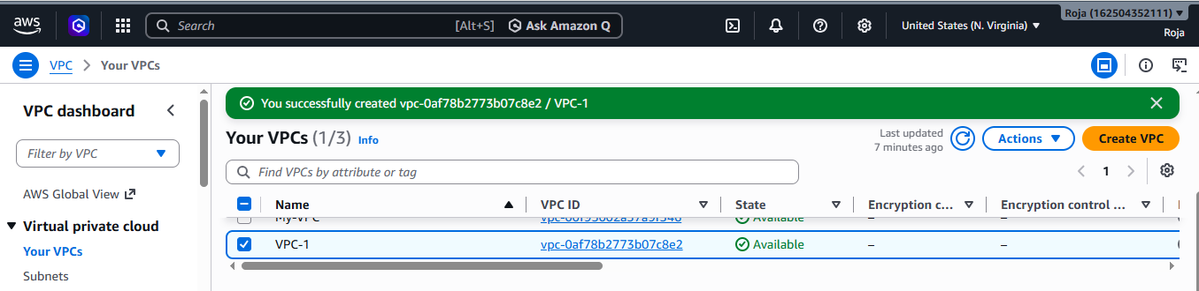

Step 2: Verify the VPC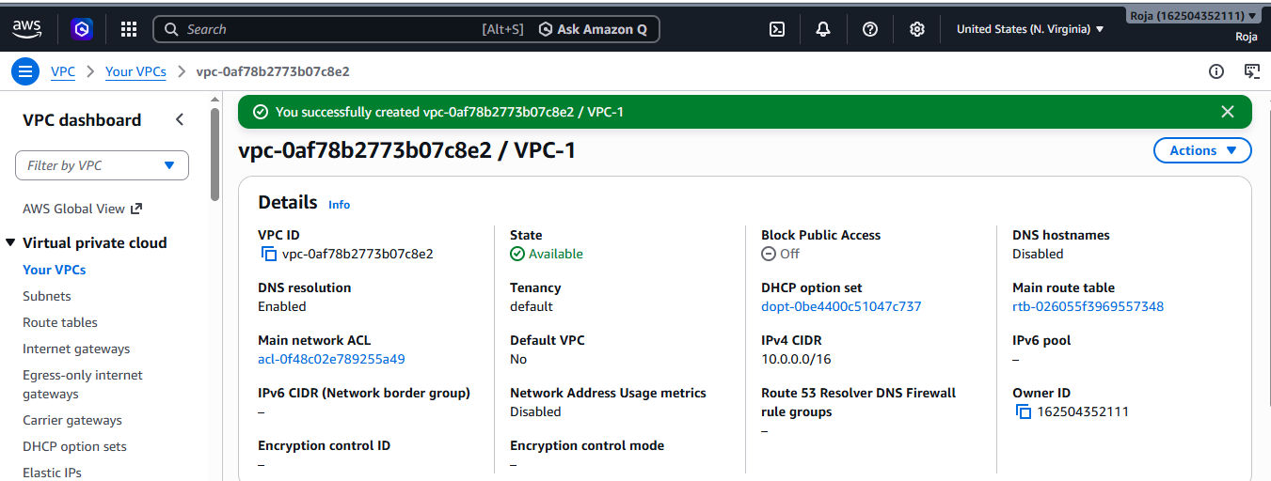

2. Create two subnets: one public subnet and one private subnet.

Objective:

To create two subnets inside the previously created VPC:
- One Public Subnet
- One Private Subnet

Both subnets will be created in the N. Virginia (us-east-1) Region.

Prerequisites:
- AWS account
- VPC already created
- AWS Management Console access
- Region selected as US East (N. Virginia) – us-east-1

Step 1: Open VPC Dashboard
- Sign in to the AWS Management Console.
- Select US East (N. Virginia) from the Region selector.
- Search for VPC.
- Open VPC.
- From the left navigation menu, select Subnets.

Step 2 : Create the Public Subnet

Click Create subnet and give details.

Below is the Public subnet:
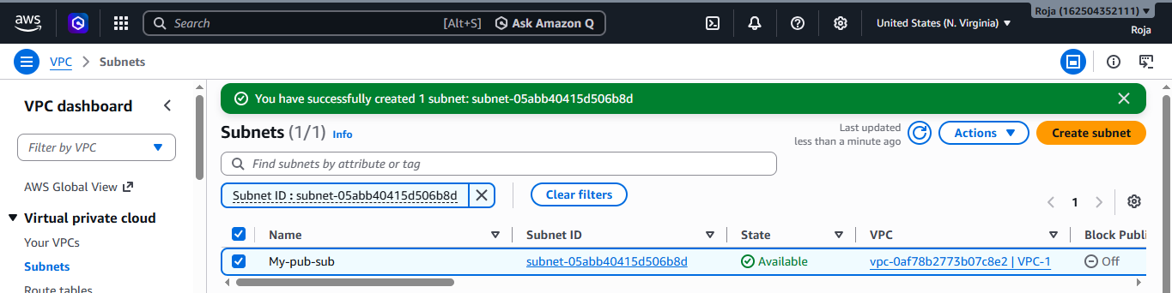
Below is the Private subnet:
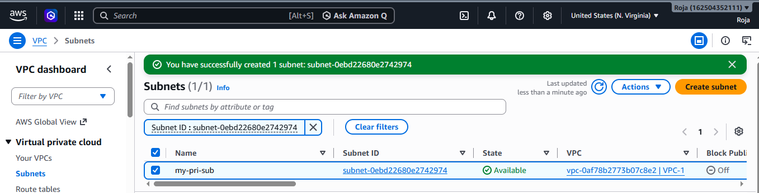
3. Attach an IGW to the VPC.

Objective
To create an Internet Gateway (IGW) and attach it to the previously created VPC, My-VPC, in the N. Virginia (us-east-1) region.

Prerequisites
- AWS account is available.
- You have access to the AWS Management Console.
- Region is US East (N. Virginia) – us-east-1.
- VPC My-VPC has already been created.
- VPC CIDR block is 10.0.0.0/16.

AWS Service Used
- Amazon VPC
- Internet Gateway (IGW)
Step 1: Open VPC Console
- Search for VPC.
- Open the VPC service.
- In the left navigation pane, select Internet gateways.
- Click Create internet gateway.

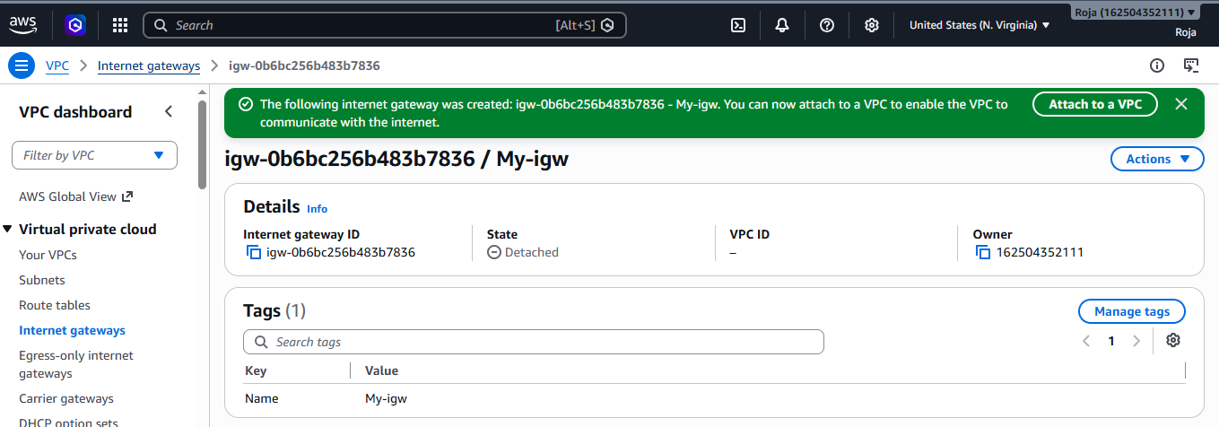

Step 2: Attach the Internet Gateway to the VPC

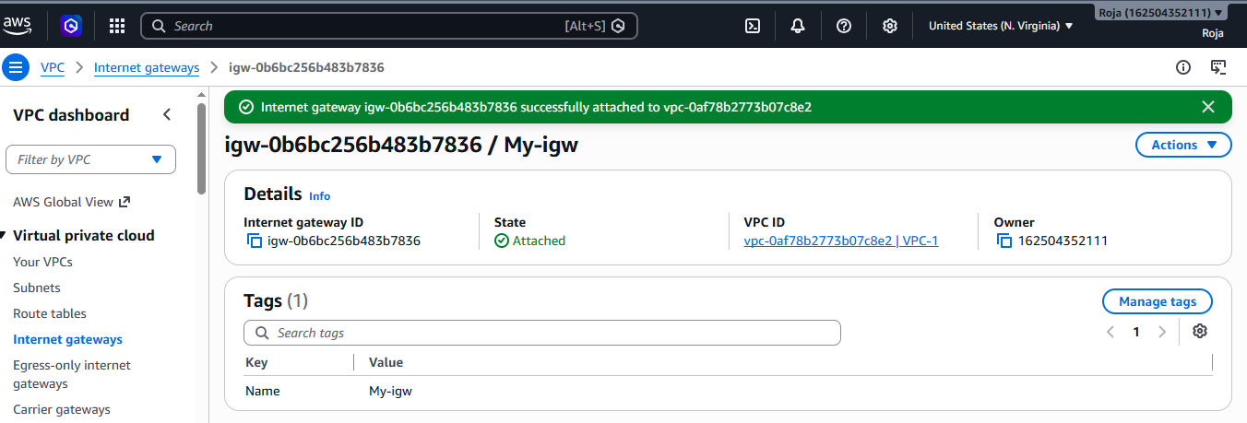
Step 3 : Verify the attachment:

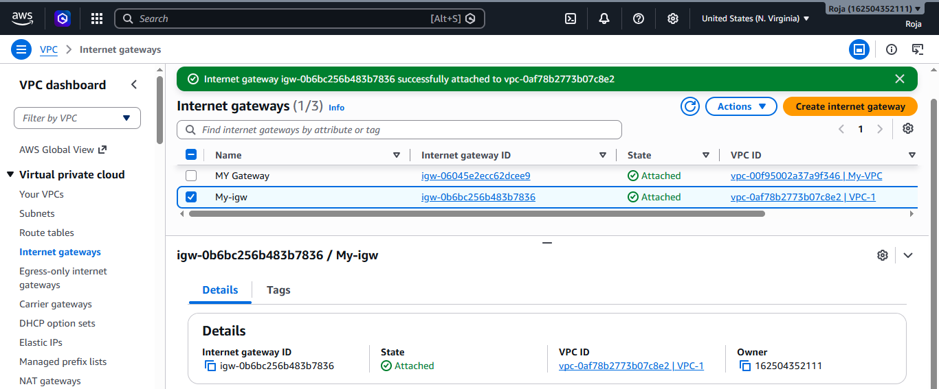

4. Create one public route table (RT) and one private route table.

Objective:
To create two route tables inside the previously created VPC:
- One Public Route Table
- One Private Route Table
The public route table will later be associated with the Public Subnet, while the private route table will be associated with the Private Subnet.

Prerequisites:
Before starting, make sure you have:
- AWS account
- Access to AWS Management Console
- Region: US East (N. Virginia) – us-east-1
- VPC: My-VPC
- VPC CIDR: 10.0.0.0/16
- Internet Gateway: My-IGW
- Public Subnet: Public-Subnet – 10.0.1.0/24
- Private Subnet: Private-Subnet – 10.0.2.0/24

Step 1: Open Route Tables
- Log in to the AWS Management Console.
- Select US East (N. Virginia) – us-east-1.
- Search for VPC.
- Open the VPC service.
- From the left navigation pane, select Route tables.
- Click Create route table.
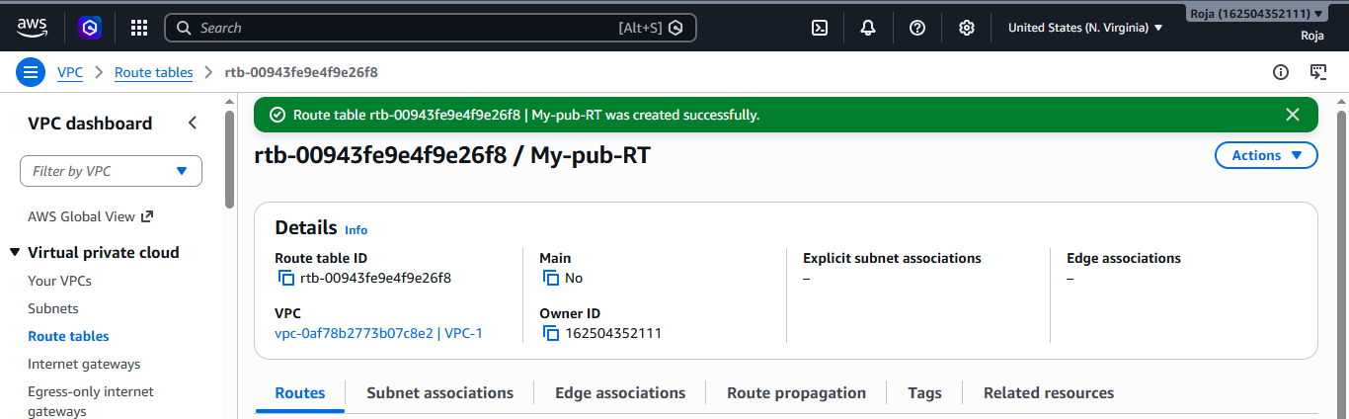

Add Internet Gateway Route

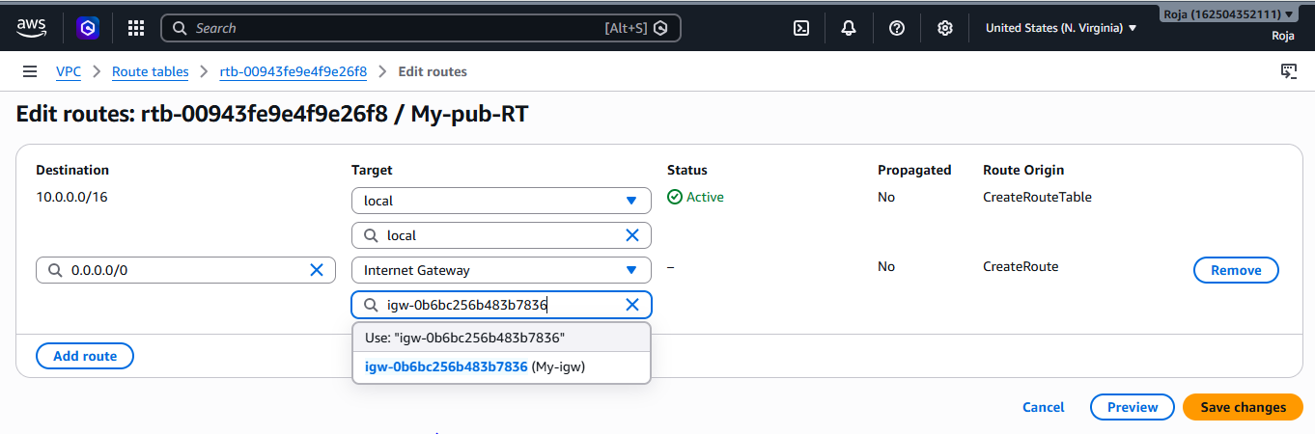
Step 2: Create the Private Route Table
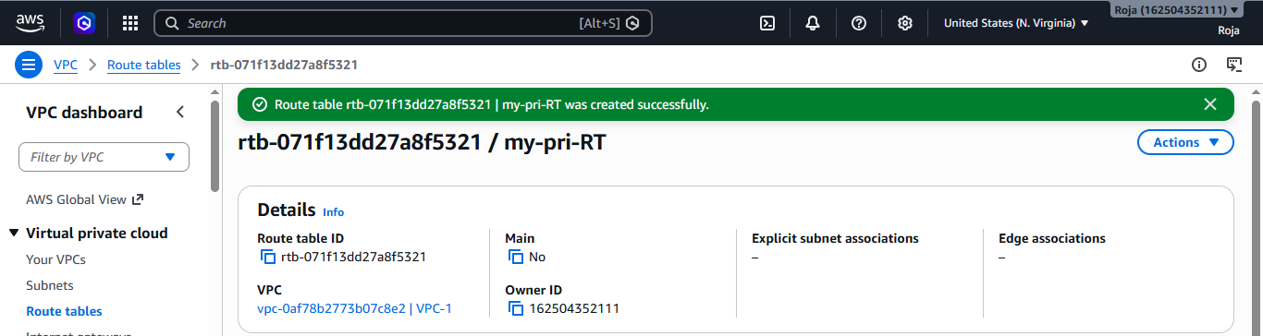

Add Internet Gateway Route
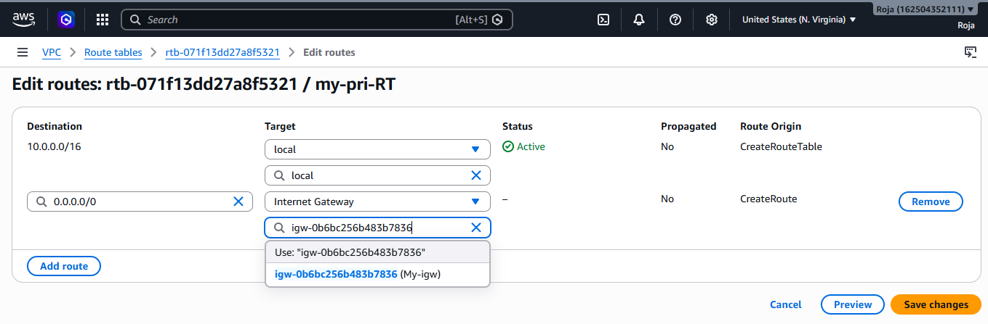

Step 3: Associate Route Table with public subnet
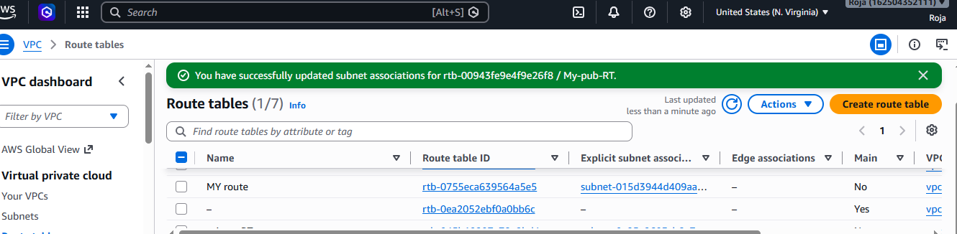
Associate Route table with Private subnet
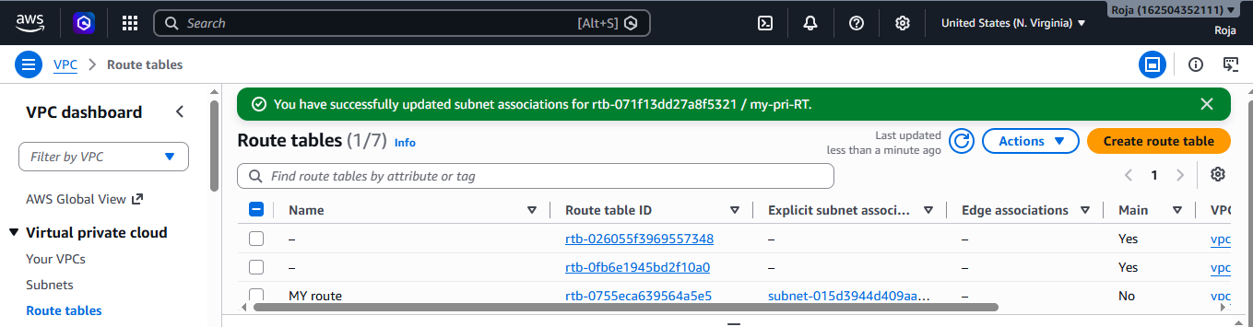

5. Deploy a NAT gateway in the public subnet and attach the NAT gateway to the private subnet.

Objective:
To create a NAT Gateway in the Public Subnet and configure the Private Subnet's route table to use the NAT Gateway for outbound internet access.
Prerequisites:
Make sure that you already have:

VPC
Public subnet
Private subnet
Internet Gateway
Public Route Table
Private Route Table.

Step 1: Open the VPC Console & Create the NAT Gateway

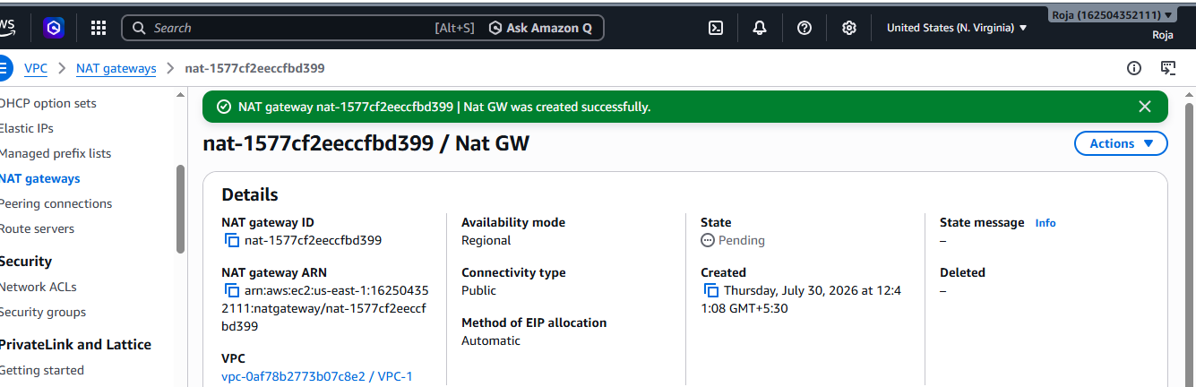

Step 2: Configure the Private Route Table
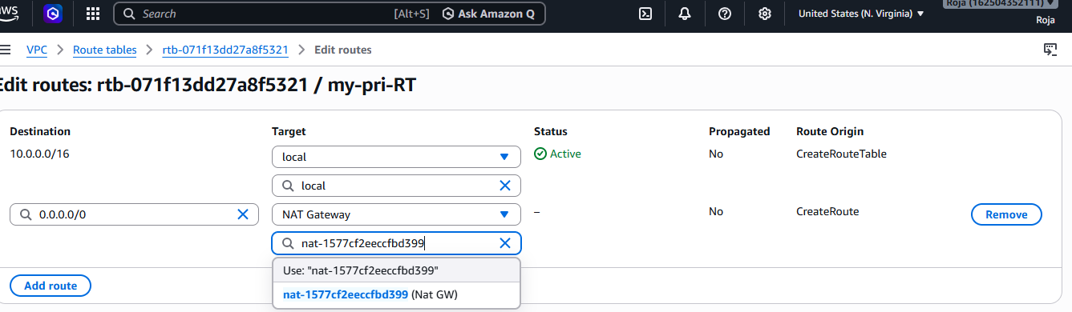
Step 3: Verify Private Subnet Association
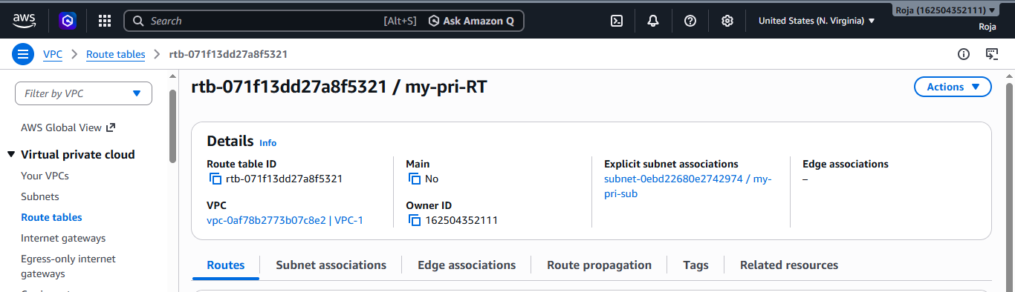

6. Create two instances, one in the public subnet and one in the private subnet.

Objective:
To launch two EC2 instances inside the previously created VPC:
- One EC2 instance in the Public Subnet
- One EC2 instance in the Private Subnet
The public instance will have internet connectivity through the Internet Gateway, while the private instance will access the internet for outbound connections through the NAT Gateway.
Prerequisites:
Make sure that you already have:

VPC
Public subnet, Private subnet
Public route table, private route table
Internet Gateway
Nat Gateway.

Step 1: Create the Public EC2 Instance

1. Open EC2 Console
- Sign in to the AWS Management Console.
- Select US East (N. Virginia) – us-east-1.
- Search for EC2.
- Open the EC2 service.
- Click Instances → Launch instances.
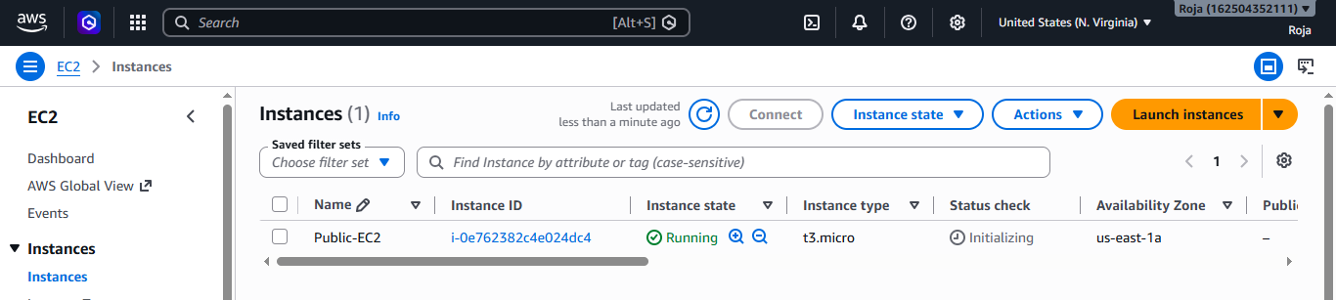

Step 2: Create the Private EC2 Instance
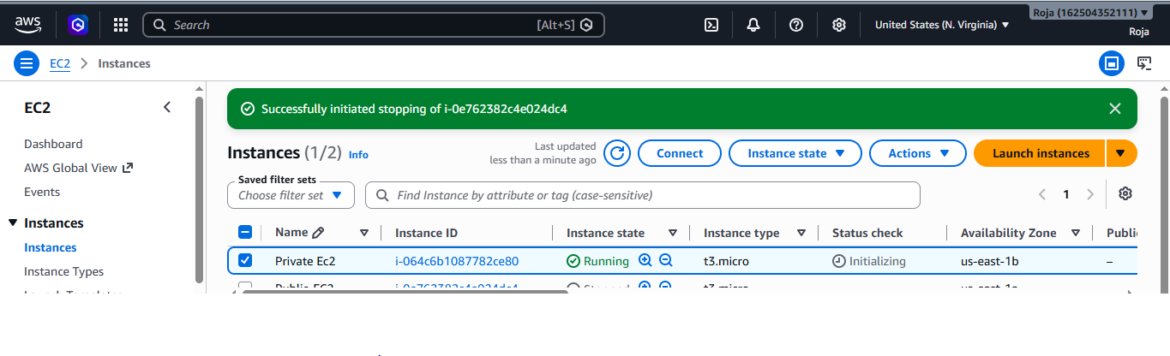
7. Deploy Apache server on both EC2 instances with a sample index.html file.

Objective:
To install and configure the Apache web server on both EC2 instances created in the previous assignment and deploy a sample index.html webpage.
The setup will be:
- Public EC2 → Apache → Public webpage
- Private EC2 → Apache → Private webpage
Prerequisites:
Make sure you have:
VPC
Public EC2, Private EC2
Public subnet, Private subnet
Nat Gateway.

Step 1: Install Apache on Public EC2

Connect to Public EC2
- Open AWS Console → EC2 → Instances.
- Select Public-EC2.
- Click Connect.
- Select EC2 Instance Connect.
- Click Connect.

Step 2: Connect to public EC2
Update packages, Install Apache, Start Apache and enable Apache
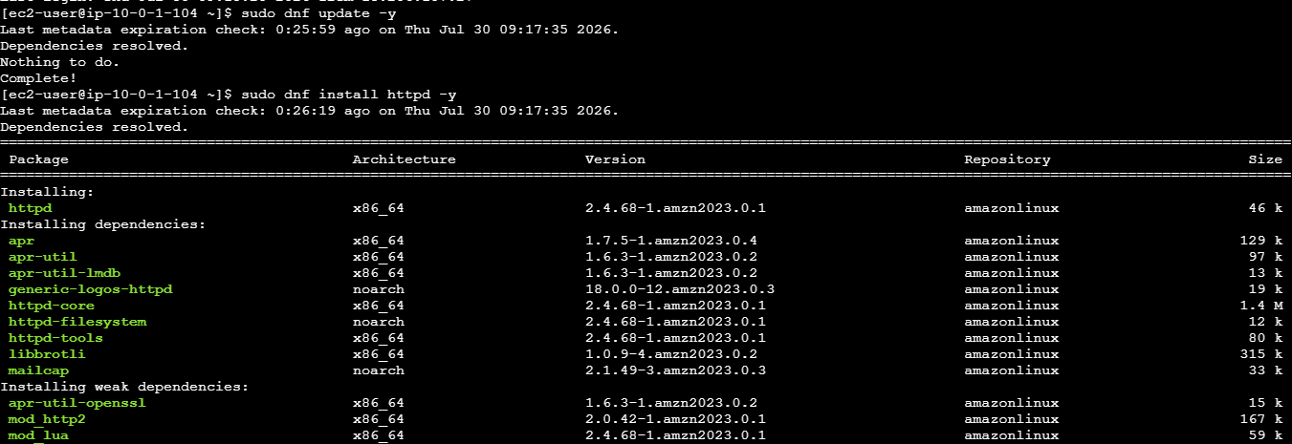
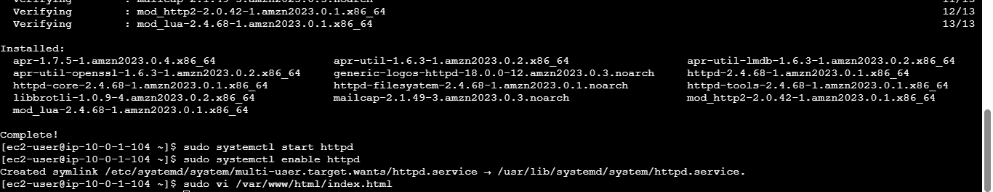

Create Sample index.html on Public EC2
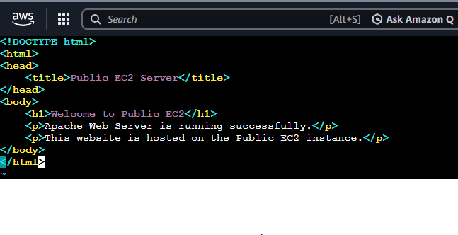
Step 3: Test the Public Apache Website
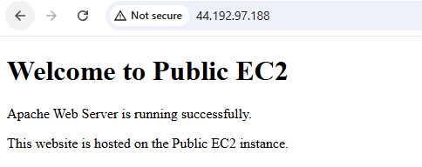
Step 4: Connect to Private EC2

Cat N.Virginia.pem key and copy the key in Git bash

Now in Public ec2 create a file using vi pem, paste the key and save it

Try to connect to Private ec2 using ssh –i pem ec2-user@private ip of private EC2

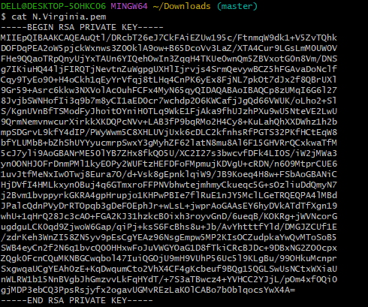

Successfully connected private ec2 from public ec2 with the help of nat gateway.

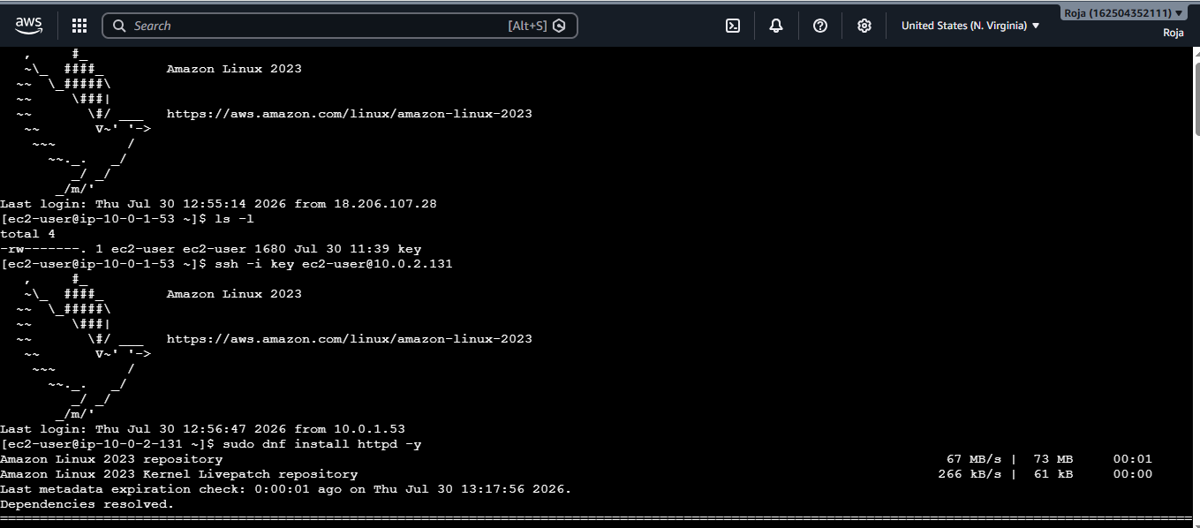

Installed, enabled, and started Apache and then checked the status.

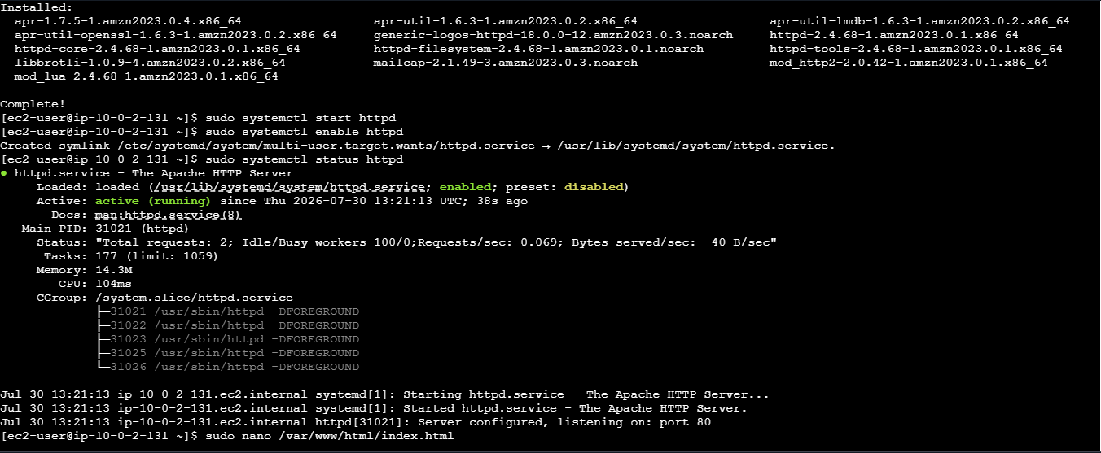

Below screenshot confirms that Apache is running successfully on Private EC2

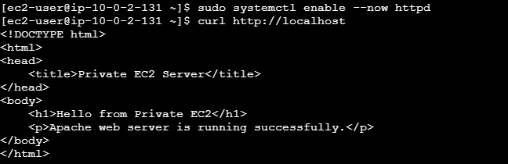

8. Create one application load balancer and attach it to both EC2 instances.

Step 1: Make sure both EC2 instances are running
Go to:
AWS Console → EC2 → Instances
Verify that you have 2 running EC2 instances.
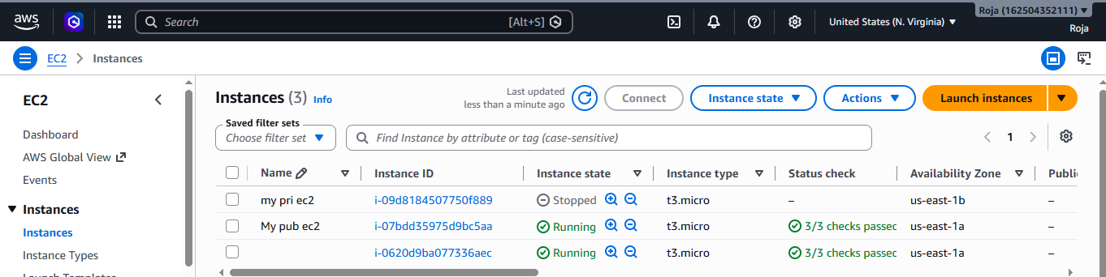
Create 2 public subnets in same region
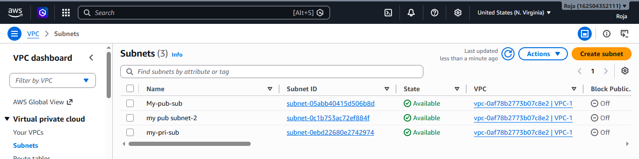

Create Load Balancer:
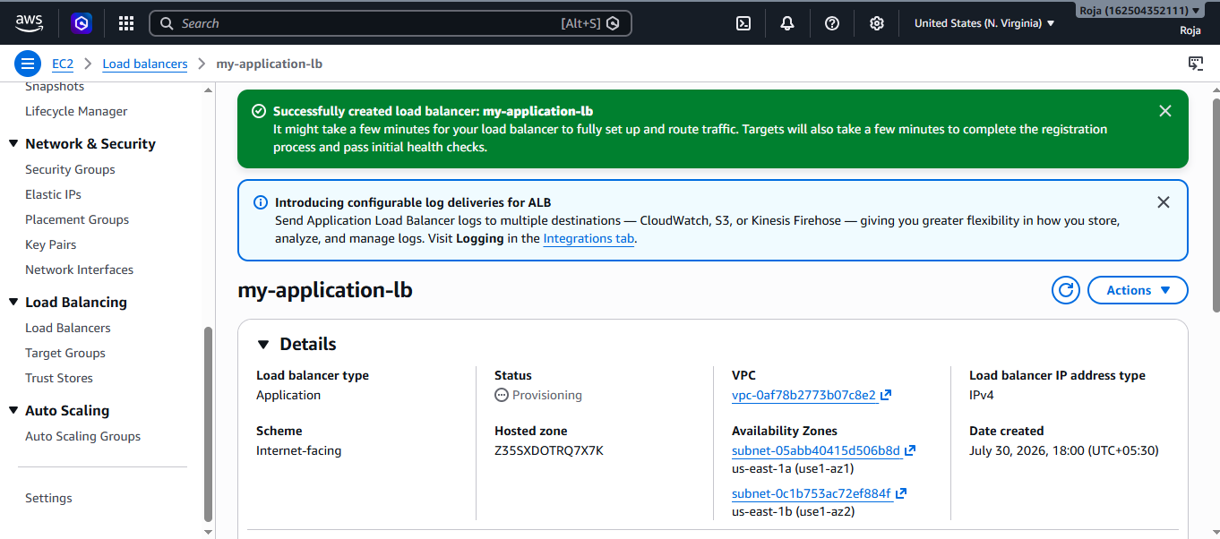
Create security Group:
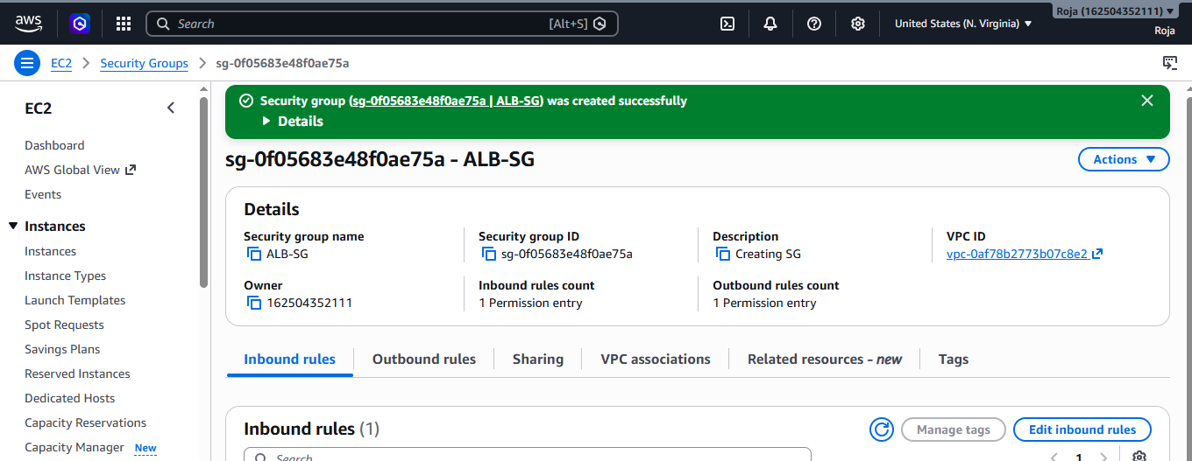
Create Targeted Group:
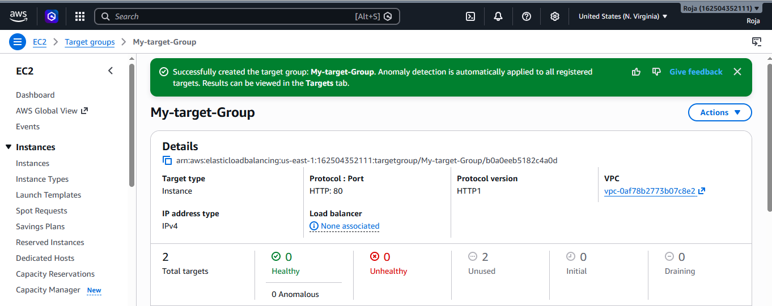
9. Store application load balancer logs in S3.

Objective:
To configure an Application Load Balancer (ALB) to store its access logs in an Amazon S3 bucket for monitoring, troubleshooting, auditing, and analysis.

Prerequisites:
Before starting, make sure you have:
- AWS account with required permissions
- Application Load Balancer already created
- An S3 bucket
- ALB and S3 bucket in the appropriate AWS Region
- Access to the AWS Management Console

AWS Services Used
- Amazon EC2
- Application Load Balancer
- Amazon S3

Step 1: Create an S3 Bucket
- Open the AWS Management Console.
- Make sure you are in US East (N. Virginia) – us-east-1.
- Search for S3.
- Open Amazon S3.
- Click Create bucket.
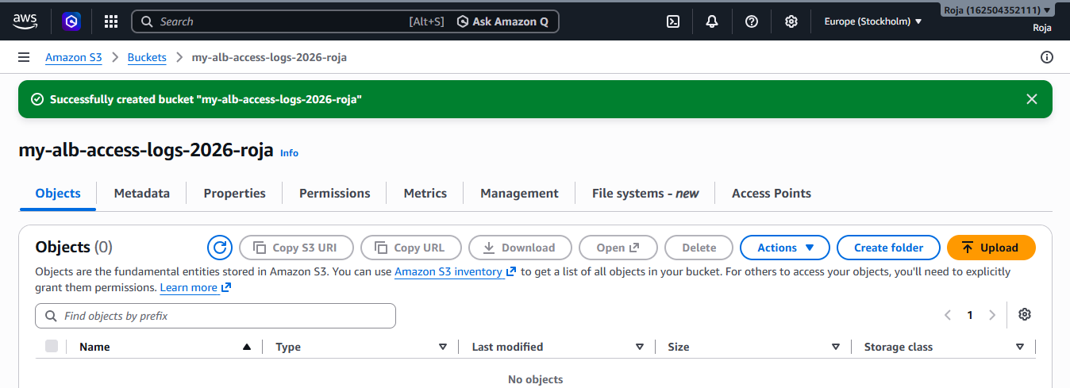

Step 2: Configure S3 Bucket Permissions

Open Bucket Permissions
- Open your S3 bucket.
- Go to the Permissions tab.
- Scroll to Bucket policy.
- Click Edit.
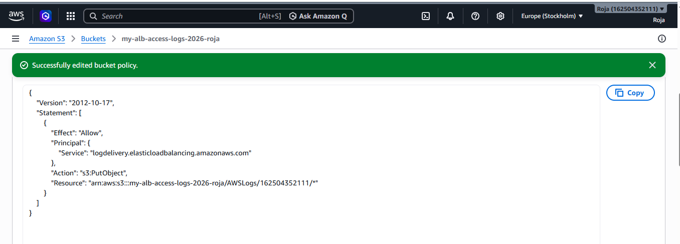

Step 3: Enable ALB Access Logs

Open Load Balancers
- Go to EC2 Console.
- From the left navigation pane, select Load Balancers.
- Select your Application Load Balancer.
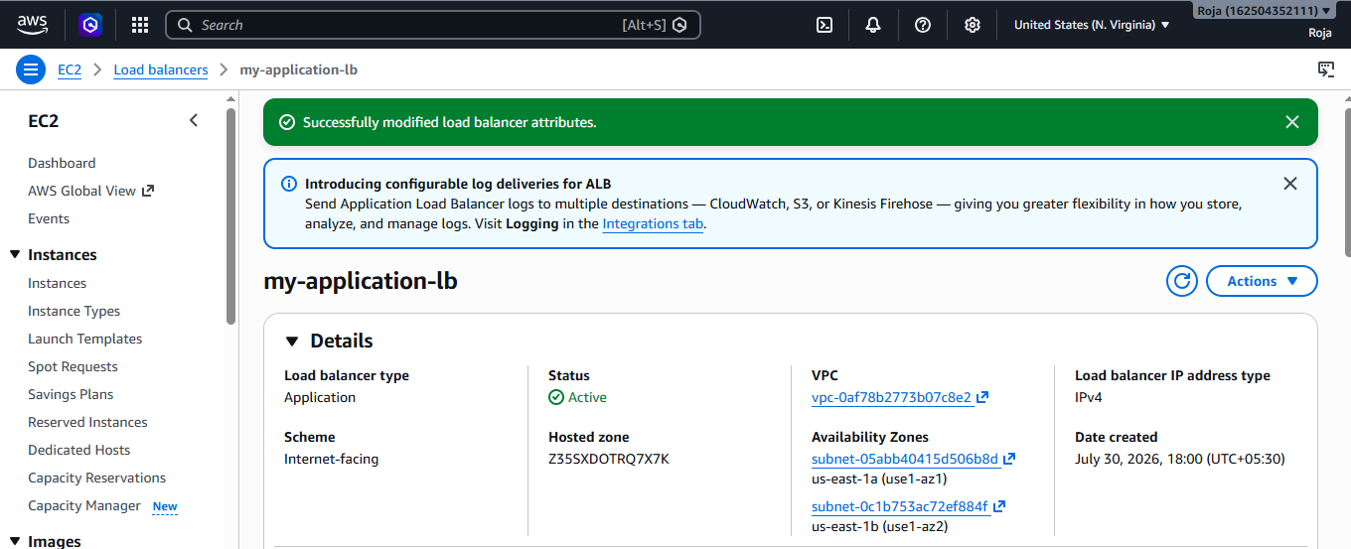
Step 4: Verify Configuration
Access logs enabled
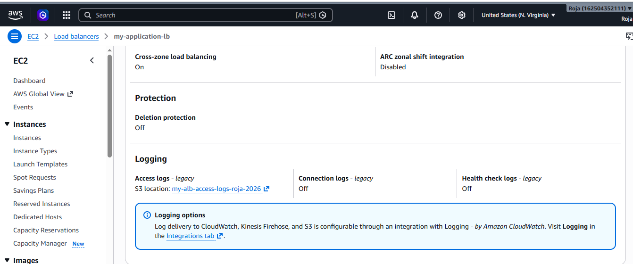
Step 5: Generate Traffic to the ALB
- Open your ALB DNS name in a browser i.e my-application-lb-190166402.us-east-1.elb.amazonaws.com
- Refresh the page several times.
- Run the command multiple times to generate requests.

Step 6: Check Logs in S3
Access logs are not necessarily visible immediately. Allow some time for log delivery.
Then:
- Open S3.
- Open your ALB log bucket.
- Look for: AWSLogs/
- Open your AWS account ID folder.
- Continue into the Region/load-balancer log structure.
You should eventually see log files similar to:
AWSLogs/
└── 123456789012/
└── elasticloadbalancing/
└── us-east-1/
└── 2026/
└── 07/
└── 30/
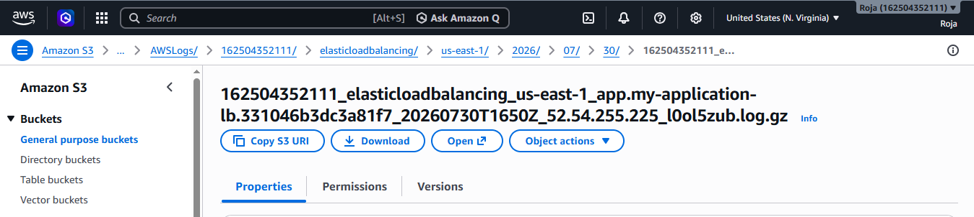

10. Store the VPC flow logs in a CloudWatch log group.

Objective:
To enable VPC Flow Logs for the previously created VPC and send the captured network traffic information to an Amazon CloudWatch Logs group.
Prerequisites:
Region, VPC, CIDR, Cloudwatch log group, IAM Role

AWS Services Used
- Amazon VPC
- VPC Flow Logs
- Amazon CloudWatch Logs
- AWS IAM

Step 1: Create a CloudWatch Log Group
- Open the AWS Management Console.
- Make sure the region is US East (N. Virginia) – us-east-1.
- Search for CloudWatch.
- Open CloudWatch.
- From the left navigation pane, select Logs → Log groups. Click Create log group.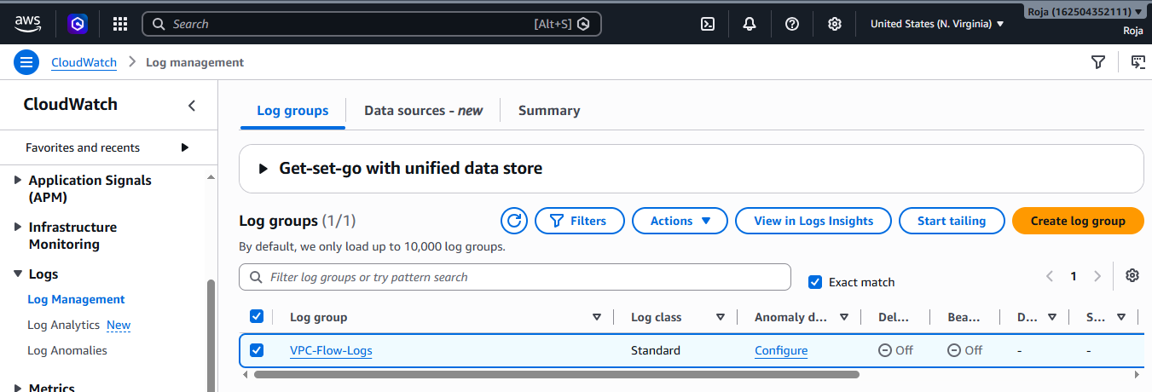

Step 2: Create IAM Role for VPC Flow Logs
VPC Flow Logs need permission to publish logs to CloudWatch.

Open IAM
- Search for IAM.
- Open IAM.
- Select Roles.
- Click Create role.
- Select Trusted Entity
- Under Trusted entity type, select:
- AWS service
- For the service/use case, select:
- EC2
- Click Next.
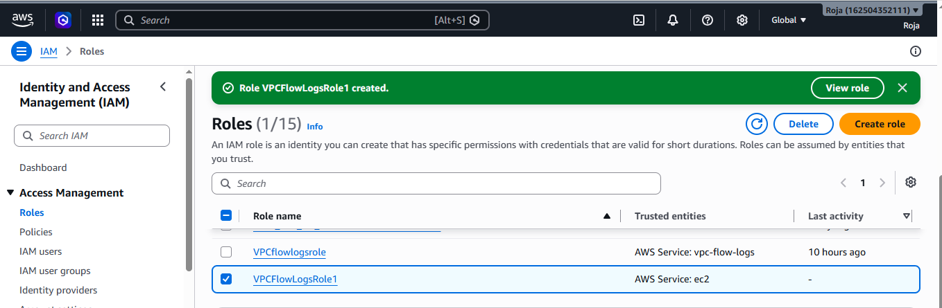

Step 3: Create VPC Flow Log

Open Your VPC
- Go to VPC.
- Select Your VPCs.
- Select
- Click Actions.
- Select Create flow log.
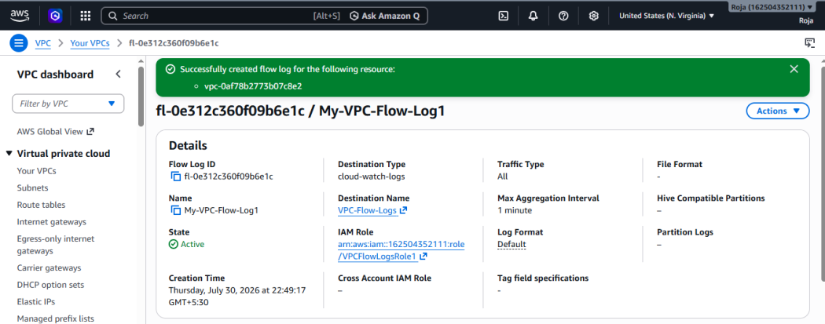
Step 4: Verify VPC Flow Logs
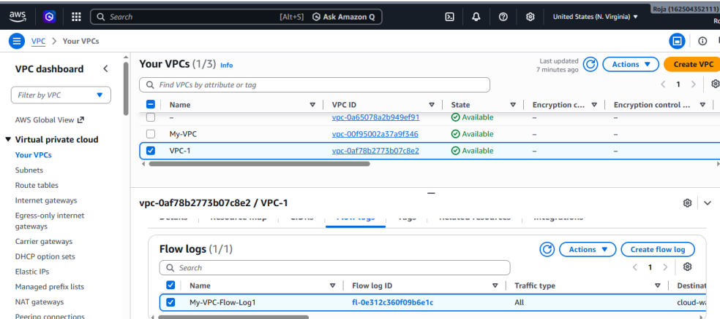
Step 5: Verify Logs in CloudWatch
.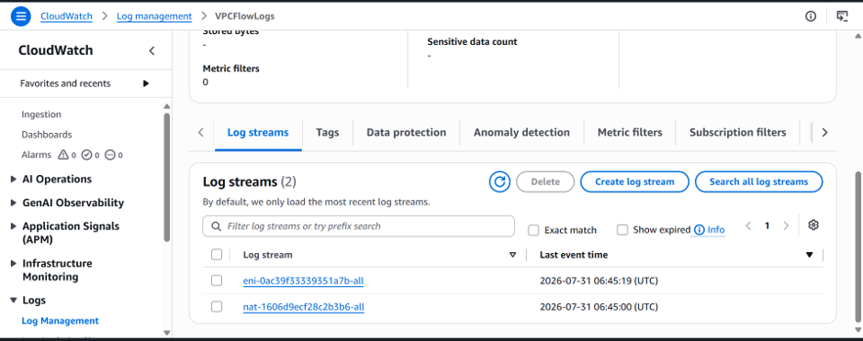

Step 6: View Log events
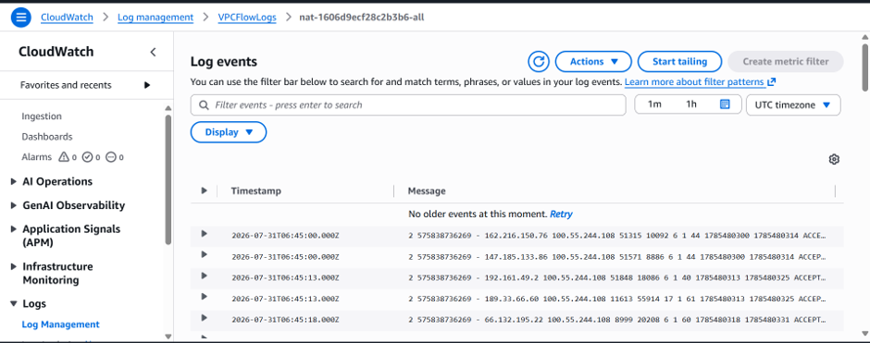

11. Create monitoring dashboards to monitor CPU utilization and to monitor the Apache service.

Objective:
To create an Amazon CloudWatch Dashboard that monitors:
- EC2 CPU Utilization
- Apache HTTP Server service status
The dashboard will help administrators monitor the health and performance of the EC2 instance.

Prerequisites
Before starting, ensure:
- An EC2 instance is running.
- Apache HTTP Server is installed.
- Apache service is running.
- The EC2 instance has internet access if CloudWatch Agent or AWS CLI needs to communicate with AWS.
- An IAM Role with appropriate CloudWatch permissions is attached to the EC2 instance.

Configure IAM Permission

Step 1: Open IAM
- Sign in to the AWS Management Console.
- Search for IAM.
- Open IAM → Roles.
- Find the IAM role attached to your EC2 instance.
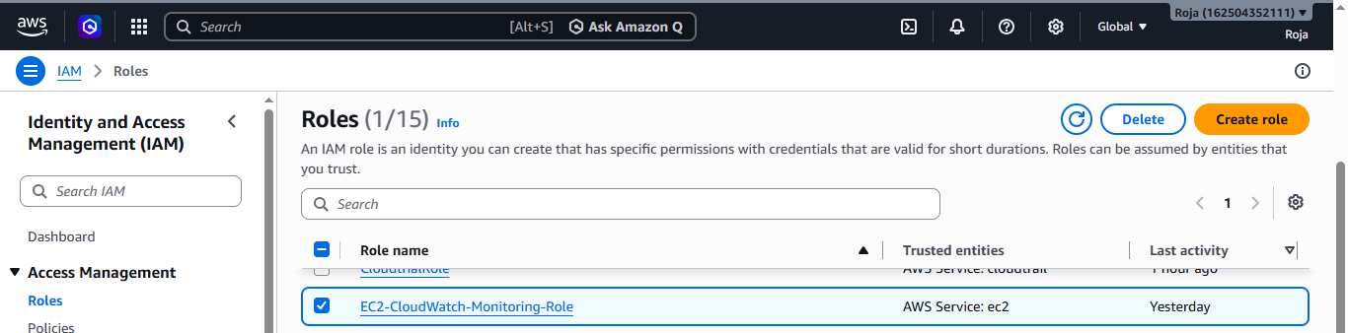

Step : 2 Monitor Apache Service
Connect to ec2 and Install Apache, Start, enable, check status of Apache.
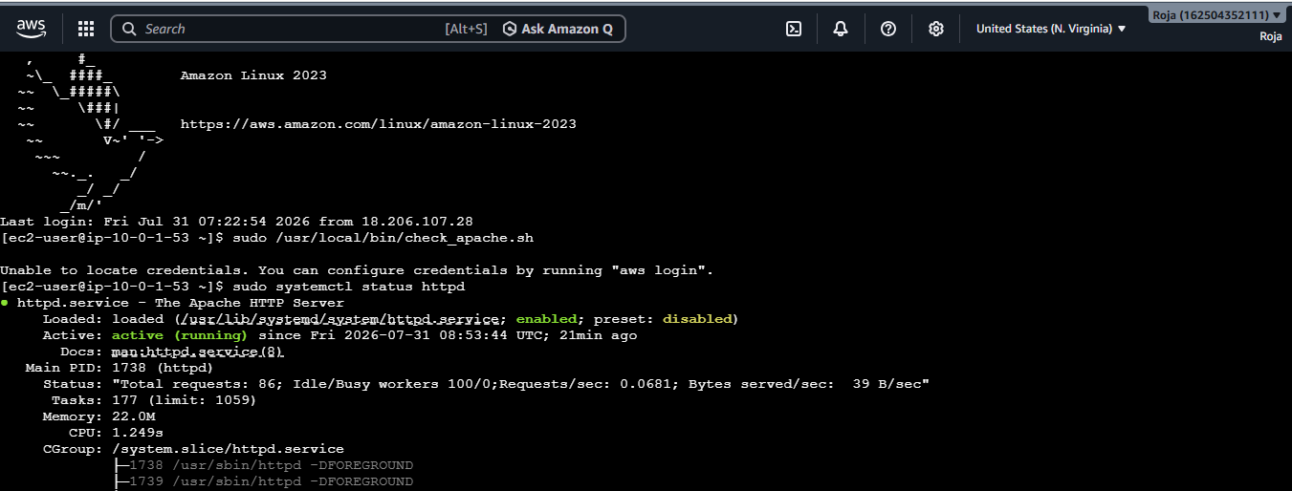
Create Apache Monitoring Script and run the script

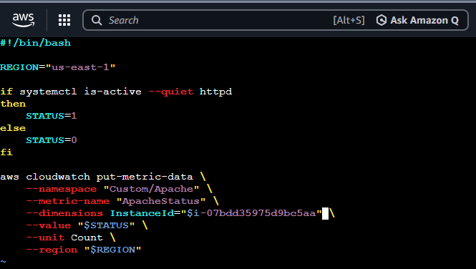
Step 3: Verify Apache Metric
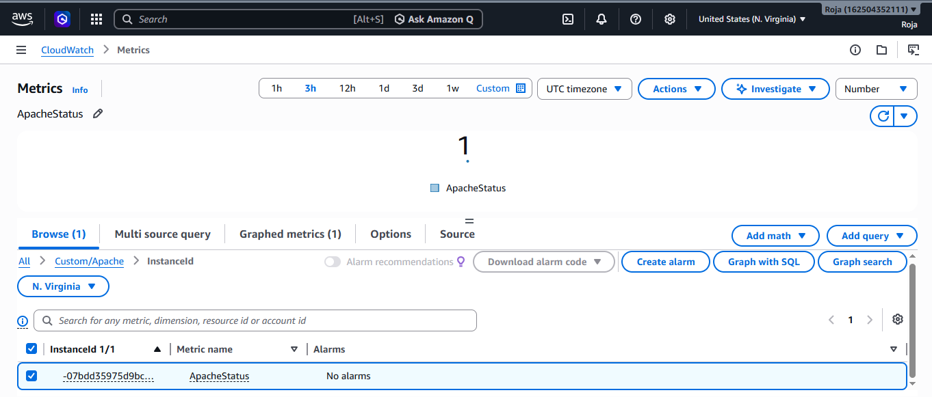
Step 4 : Verify the Dashboard
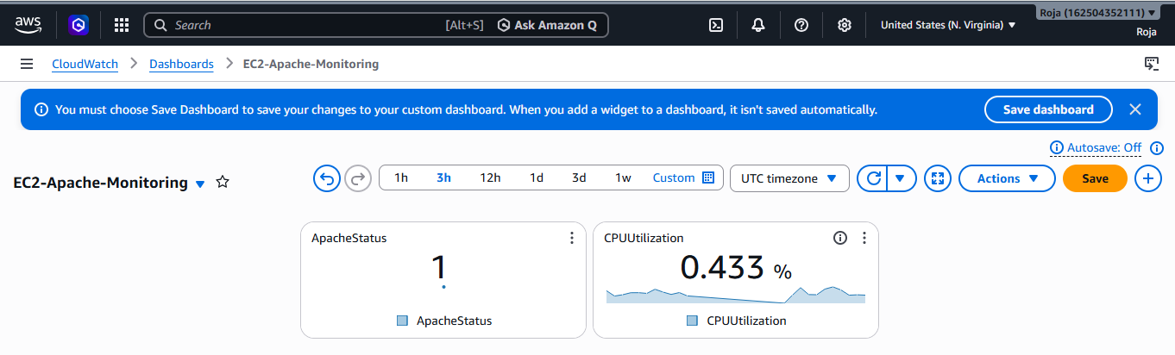

12. If CPU utilization is more than 70%, then it should trigger auto scaling and launch new instance.

Objective
To configure Amazon EC2 Auto Scaling so that when the average CPU utilization of instances becomes greater than 70%, the Auto Scaling Group automatically launches an additional EC2 instance.

Prerequisites
Before starting, make sure you have:
- An AWS account
- An EC2 instance
- A VPC
- At least one subnet
- A security group
- An EC2 key pair
- An AMI to use for the new instances
Important: Auto Scaling should launch instances from a Launch Template rather than manually copying your existing EC2 instance. A launch template defines the AMI, instance type, security group, key pair, and other launch settings.
Create a Launch Template

Step 1: Open EC2
- Select Launch Templates from the left navigation menu.
- Click Create launch template.
- Enter Launch Template Name: Apache-AutoScaling-Template
- Description: Launch template for Apache Auto Scaling
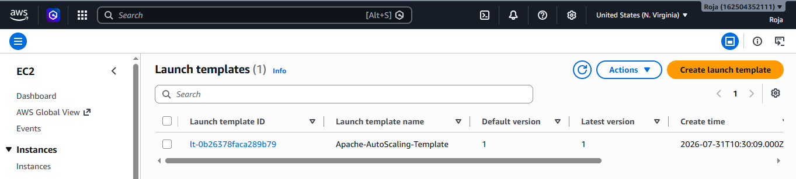
Step 2: Create Auto Scaling Group
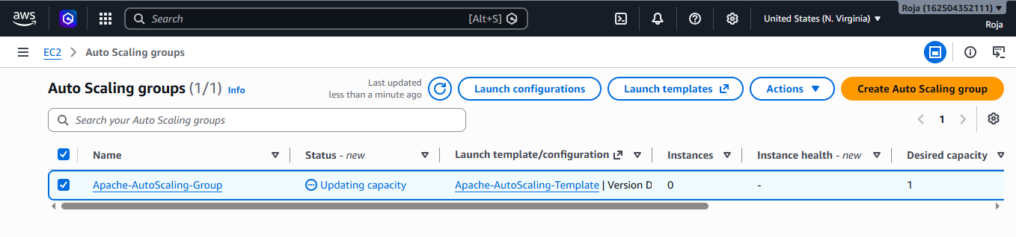

Step 3: Verify Initial Instance
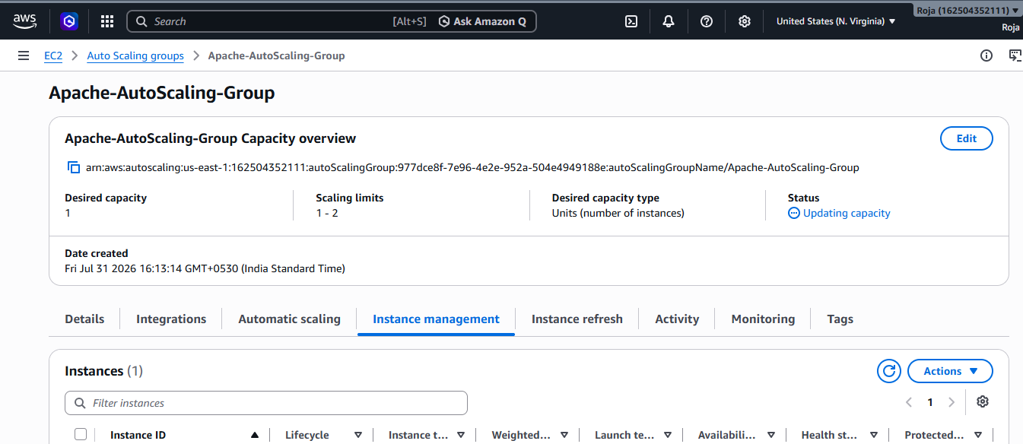
Step 4: Create Scaling Policy
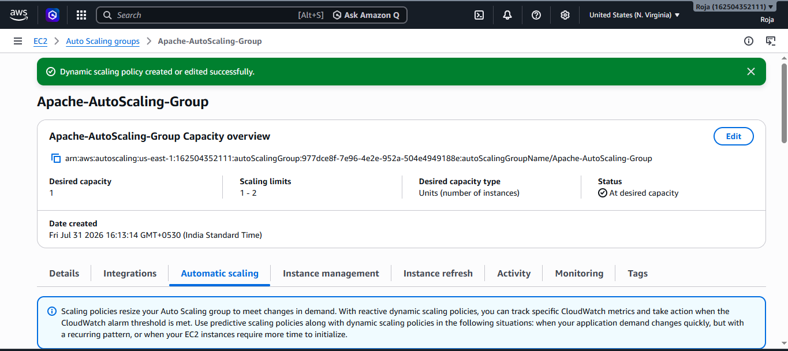

5. Create CloudWatch Alarm
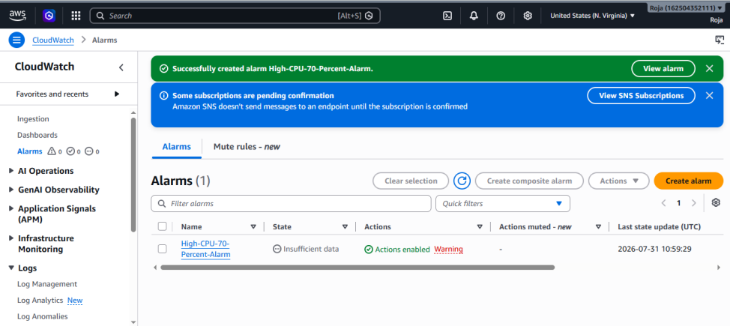

6. Monitor CloudWatch Alarm
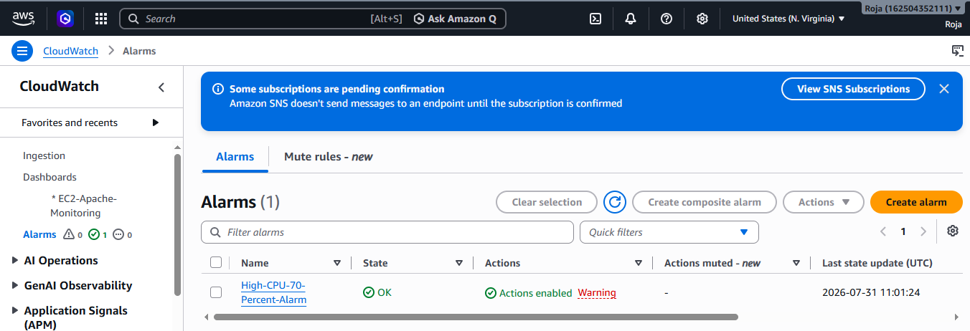

7. Verify Auto Scaling
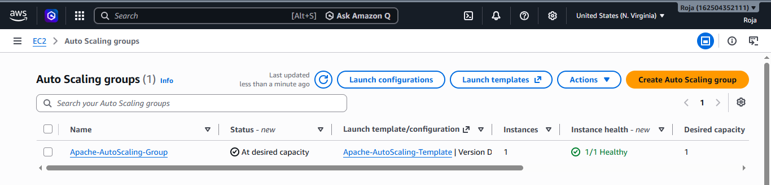
8. Configure Scaling Action
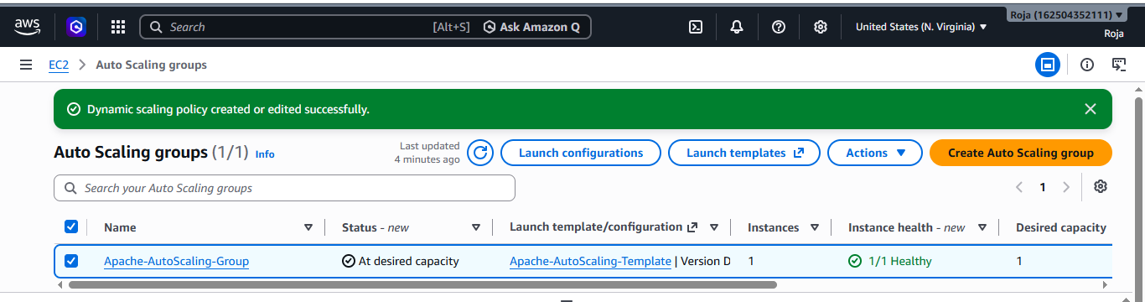
9. Test Auto Scaling
Connect to the EC2 Instance
Generate CPU Load using yes > /dev/null & and use top command to consume CPU and stop it after reaching 70%.
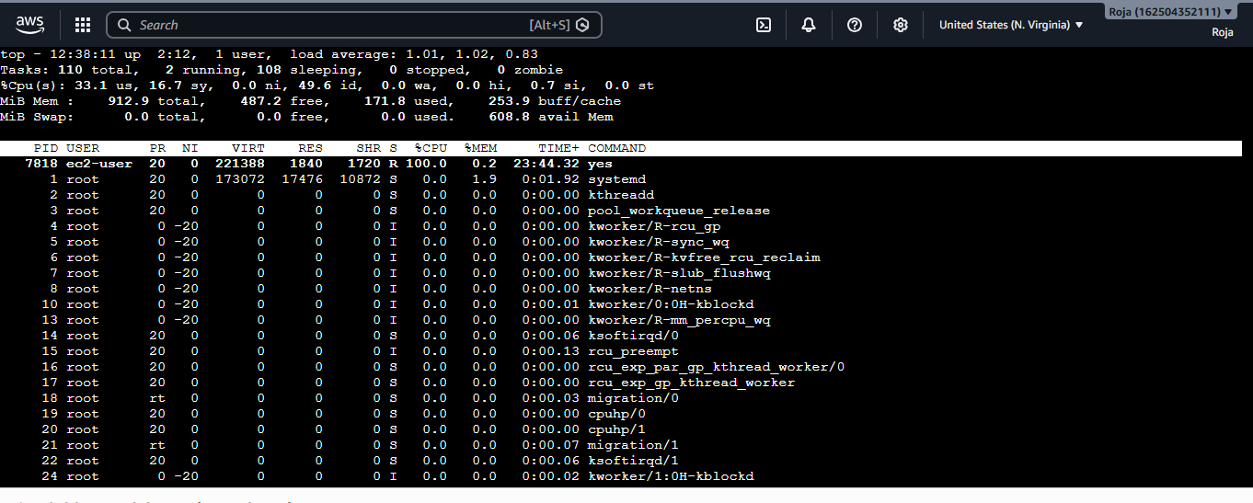

10. Monitor CloudWatch Alarm
